Hi, my name is Richard Binckley and I am interested in getting my interior reupholstered. What I'm thinking is I would remove the bucket seats and the back seat and ship or deliver to you.
What I'm looking for is replacement the same or similar to the current material which is from an 1990 era Ford Probe. Here are some photos of them currently:
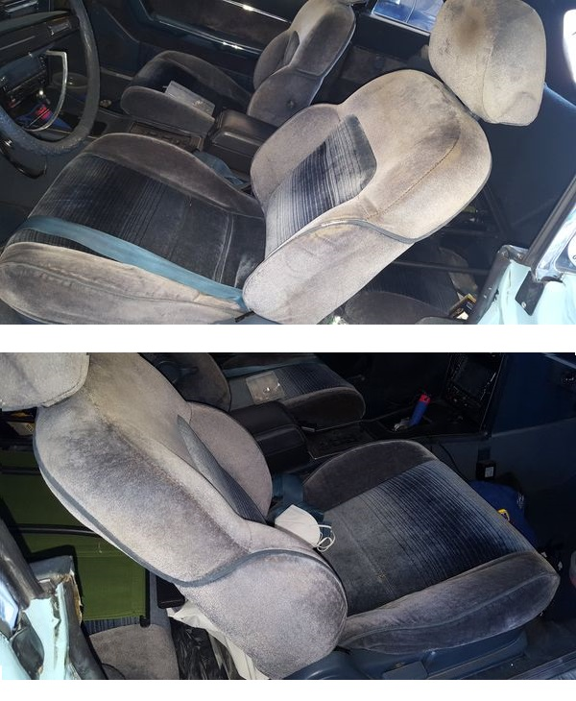

The buckets will need new seat foam, but the seat backs of the buckets seem to be in reusable shape.

For the back seat I want it to be more sculptured than what done before. I would like for them to look more like the bucket seats with raised areas outside the inserts, similar in shape to these:
